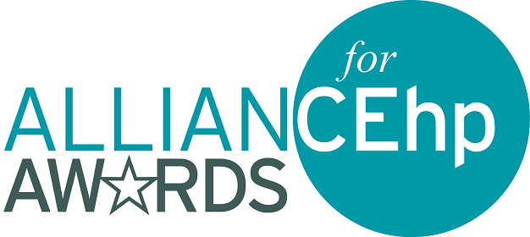

ABOUT THE 2025 APPLICATION PROCESS

**For specific criteria for each award, including eligibility and evaluation information, as well as details regarding the content of your submission, visit the** [**Alliance Awards webpage**](https://www.acehp.org/What-We-Do/Awards-Recognition)**. Overall eligibility requirements include:**

* The nominator must be an Alliance member, and at least one of the primary individuals involved in the planning, development, and implementation of a nominated activity/endeavor must be a member of the Alliance and listed as a nominee in the applicant information tasks.
* A nominated activity/endeavor must have been initiated within the specified time defined within the award eligibility information. This differs by award type.
* A nominated activity/endeavor may not be nominated for any other Alliance award in the same year nor have previously received any other Alliance annual award.
* Only one application per nominee (person or organization) may be submitted per award category. This includes individuals or organizations who participated as a collaborator on the activity, project, or initiative.
* Nominees (person or organization) may submit for no more than two award categories. This includes individuals or organizations who participated as a collaborator on the activity, project, or initiative.
* Nominees (person or organization) may not submit in an award category that they have won the previous year. This includes individuals and organizations who participated as a collaborator on the activity, project, or initiative.
* Commercial supporters may or may not be listed as nominees, depending on award eligibility information; please review specific award criteria for restrictions.
* The Awards Committee is made up of volunteers from across the member sections. To ensure the process of selecting winners is fair for all applicants, we do not allow employees/consultants of the organization submitting the nomination to review or score the award submission. This extends to educational partners and commercial supporters of the nominated activity/endeavor as well.

**Tips:**

* Tip 1: Read the award application instructions carefully … and follow them.
* Tip 2: Ensure your activity/project and your nominees meet all the requirements specific to the award for which you are applying.
* Tip 3: Be clear and concise in your descriptions (Graphics can be helpful).
* Tip 4: Provide enough information for the awards committee to review…but not too much information.
* Tip 5: Be specific about how and which National Learning Competencies were incorporated.
* Tip 6: Ensure you or your organization are not listed on more than the allotted number of submissions, which could result in disqualification.